Lab assignment # 8

Object Oriented Programming

# Submitted by

[Imtanan Mehmood]

SP20-BSE-039 (Registration number)

# Github link

[https://github.com/imtanan-m/OOP21.git]

# Scenario

**Home Activity:**

(The Person, Student, Employee, Faculty, and Staff classes) Design a class named Person and its two subclasses named Student and Employee. Design two more classes; Faculty and Staff and extend them from Employee. The detail of classes is as under:

* A person has a name, address, phone number, and email address.
* A student has a status (String)
* An employee has an office, salary, and date hired. Use the Date class to create an object for date hired.
* A faculty member has office hours and a rank.
* A staff member has a title.
* Create display method in each class

# Code

**Person:**

public class Person {

protected String name;

protected String address;

protected int phoneNumber;

protected String email;

public Person(String name, String address, int phoneNumber, String email)

{

this.name = name;

this.address = address;

this.phoneNumber = phoneNumber;

this.email = email;

}

public void display()

{

System.out.println("Name: " + name + "\nAddress: " + address + "\nPhone number: " + phoneNumber + "\nEmail: " + email);

}

**Student:**

public class Student extends Person {

private String status;

public Student(String name, String address, int phone, String email, String status)

{

super(name, address, phone, email);

this.status = status;

}

//displaying

@Override

public void display()

{

System.out.println("Student data: ");

super.display();

System.out.println("Status: " + status);

}

**Employee:**

public class Employee extends Person {

protected String office;

protected double salary;

protected Date DateOfHire;

public Employee(String name, String address, int phone, String email, String office, int salary, Date obj)

{

super(name, address, phone, email);

this.office = office;

this.salary = salary;

this.DateOfHire = obj;

}

//displaying

@Override

public void display()

{

super.display();

System.out.println("Office: " + office + "\nSalary: " + salary + "\nHired date: " + DateOfHire);

}

}

class Date

{

int day;

int month;

int year;

public Date(int d, int m, int y)

{

day = d;

month = m;

year = y;

}

public String toString()

{

String s = day+"/"+month+"/"+year;

return s;

}

**Faculty:**

public class Faculty extends Employee {

private int officeHours;

private String rank;

public Faculty(String name, String address, int phone, String email, String office, int salary, Date obj, int officeHours, String rank)

{

super(name, address, phone, email, office, salary, obj);

this.officeHours = officeHours;

this.rank = rank;

}

//displaying

@Override

public void display()

{

System.out.println("\nFaculty Member Data: ");

super.display();

System.out.println("Office hours: " + officeHours + "\nRank: " + rank );

}

**Staff:**

public class Staff extends Employee {

private String title;

public Staff(String name, String address, int phone, String email, String office, int salary, Date obj, String title)

{

super(name, address, phone, email, office, salary, obj);

this.title = title;

}

//displaying

@Override

public void display()

{

System.out.println("\nStaff Member Data: ");

super.display();

System.out.println("Title: " + title);

}

**Runner:**

public class L8HomeAct_Runner {

public static void main(String[] args) {

//student details

Student std = new Student("Imtanan Mehmood", "House No 12, Street No 3, Islamabad", 23131, "imtanan002@gmail.com", "Undergraduate");

std.display();

///faculty details

Date d1 = new Date(02, 12, 2018);

Faculty f = new Faculty("Muhammad Musa", "House No 13, Street No 3, Islamabad", 31231, "muhammadmusa2002@gmail.com", "Nayatel", 30000, d1, 5, "Accountant");

f.display();

//staff details

Date d2 = new Date(17, 04, 2020);

Staff s = new Staff("Tani", "House No 4, street No 3, Islamabad", 23123, "tani2020@gmail.com", "Touch Stone", 90000, d2, "Worker");

s.display();

}

# Output

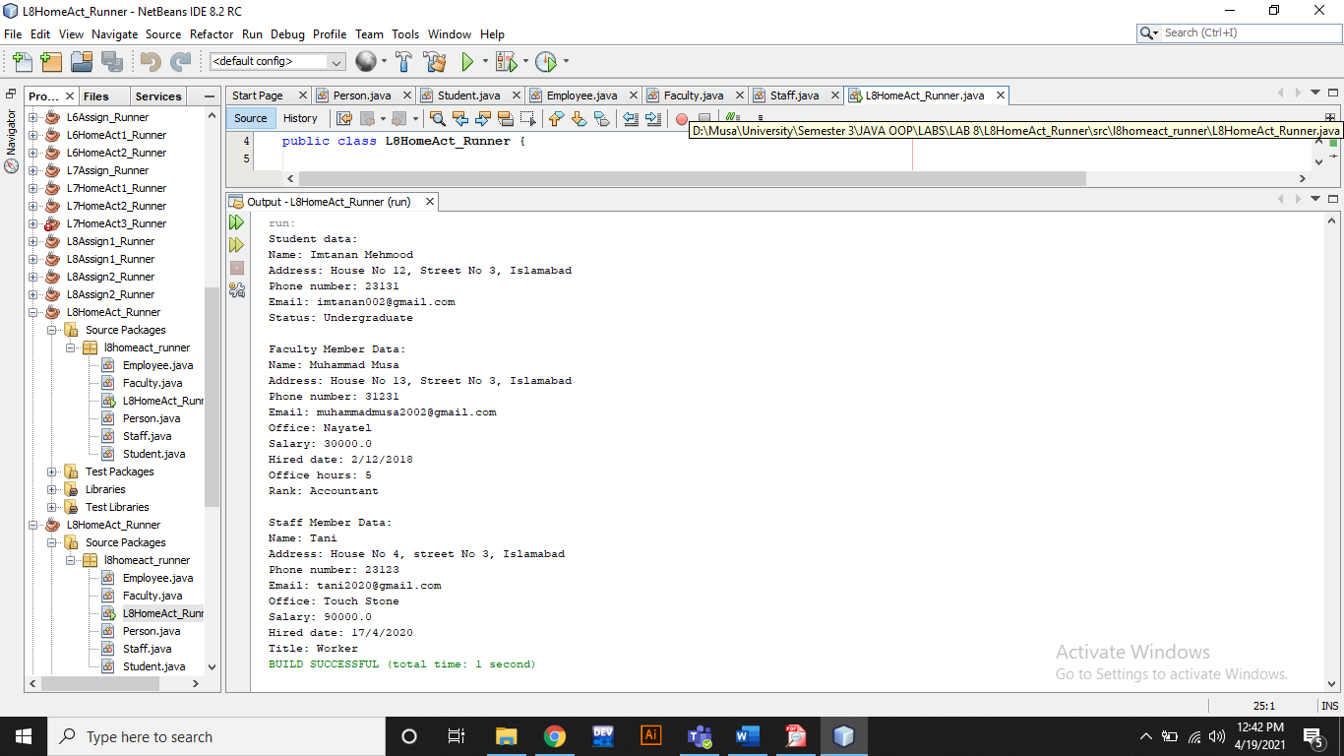

# Scenario

**Assignment 1:**

Imagine a publishing company that markets both book and audio-cassette versions of its works. Create a class publication that stores the title and price of a publication. From this class derive two classes:

1. book, which adds a page count and
2. tape, which adds a playing time in minutes.

Each of these three classes should have set() and get() functions and a display() function to display its data. Write a main() program to test the book and tape class by creating instances of them, asking the user to fill in their data and then displaying the data with display().

# Code

**Publications:**

public class L8Assign1_Runner {

public static void main(String[] args) {

Scanner input = new Scanner(System.in);

//displaying title

System.out.print("Enter book title: ");

String title = input.nextLine();

//displaying price

System.out.print("Enter price: ");

int price = input.nextInt();

//displaying pages

System.out.print("Enter number of pages: ");

int pageCount = input.nextInt();

//displaying playing time

System.out.print("Enter playing time in minutes: ");

int playingTime = input.nextInt();

//displaying book

System.out.print("\nBook: ");

Book b = new Book(title, price, pageCount);

b.display();

//displaying tape

System.out.print("\nTape: ");

Tape t = new Tape(title, price, playingTime);

t.display();

}

**Book:**

public class Book extends Publication {

private int pageCount;

public Book(String title, int price, int pageCount)

{

super(title, price);

this.pageCount = pageCount;

}

//setter

public void setPageCount(int pageCount)

{

this.pageCount = pageCount;

}

//getter

public int getPageCount()

{

return pageCount;

}

//displaying

public void display()

{

super.display();

System.out.println("Number of pages: " + pageCount);

}

**Tape:**

public class Tape extends Publication {

private int playingTime; //in minutes

public Tape(String title, int price, int playingTime)

{

super(title, price);

this.playingTime = playingTime;

}

//setter

public void setPlayingTime(int playingTime)

{

this.playingTime = playingTime;

}

//getter

public int getPlayingTime()

{

return playingTime;

}

//displaying

public void display()

{

super.display();

System.out.println("Playing time: " + playingTime + " minutes");

}

**Runner:**

public class L8Assign1_Runner {

public static void main(String[] args) {

Scanner input = new Scanner(System.in);

//displaying title

System.out.print("Enter book title: ");

String title = input.nextLine();

//displaying price

System.out.print("Enter price: ");

int price = input.nextInt();

//displaying pages

System.out.print("Enter number of pages: ");

int pageCount = input.nextInt();

//displaying playing time

System.out.print("Enter playing time in minutes: ");

int playingTime = input.nextInt();

//displaying book

System.out.print("\nBook: ");

Book b = new Book(title, price, pageCount);

b.display();

//displaying tape

System.out.print("\nTape: ");

Tape t = new Tape(title, price, playingTime);

t.display();

}

# Output

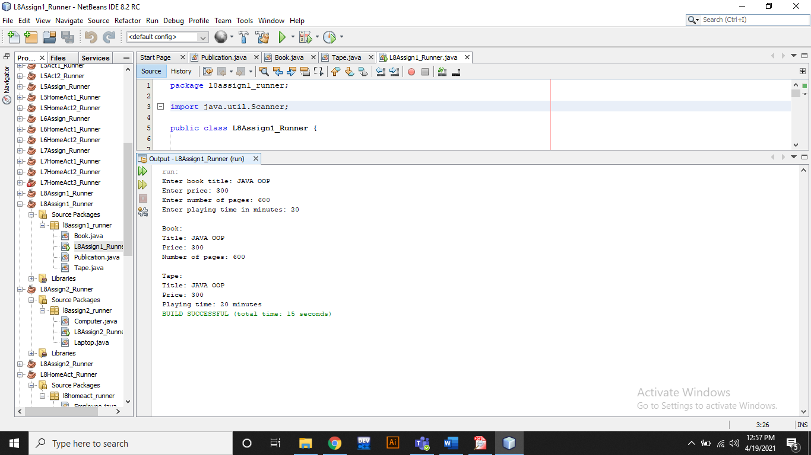

# Scenario

**Assignment 2:**

Write a base class Computer that contains data members of wordsize(in bits), memorysize (in megabytes), storagesize (in megabytes) and speed (in megahertz). Derive a Laptop class that is a kind of computer but also specifies the object’s length, width, height, and weight. Member functions for both classes should include a default constructor, a constructor to inialize all components and a function to display data members.

# Code

**Computer:**

public class Computer {

protected int wordsize; //in bits

protected int memorysize; //in megabytes

protected int storagesize; //in megabytes

protected double speed; //in megahertz

public Computer(int wordsize, int memorysize, int storagesize, double speed)

{

this.wordsize = wordsize;

this.memorysize = memorysize;

this.storagesize = storagesize;

this.speed = speed;

}

public Computer()

{

this.wordsize = 32;

this.memorysize = 1024;

this.storagesize = 800;

this.speed = 15.3;

}

//displaying

public void display()

{

System.out.println("Wordsize: " + wordsize + " bits" + "\nMemorysize: " + memorysize + " megabytes" + "\nStoragesize: " + storagesize + " megabytes" + "\nSpeed: " + speed + " megahertz");

}

**Laptop:**

public class Laptop extends Computer {

private int length;

private int width;

private int height;

private int weight;

public Laptop(int wordsize, int memorysize, int storagesize, double speed, int length, int width, int height, int weight)

{

super(wordsize, memorysize, storagesize, speed);

this.length = length;

this.width = width;

this.height = height;

this.weight = weight;

}

public Laptop()

{

super();

this.length = 10;

this.width = 5;

this.height = 15;

this.weight = 30;

}

//displaying

public void display()

{

System.out.println("Laptop Data:");

super.display();

System.out.println("Length: " + length + " inches" + "\nWidth: " + width + " cm" + "\nHeight: " + height + " cm" + "\nweight: " + weight + " kg" + "\n");

}

**Runner:**

public class L8Assign2_Runner {

public static void main(String[] args) {

{

Laptop L1 = new Laptop();

L1.display();

Laptop L2 = new Laptop(64, 2048, 1600, 30.6, 20, 10, 25, 50);

L2.display();

}

}

# Output

